Create An Account In SendGrid:

In IBM Project workspace there is a website link is there to create an account in the SendGrid using those resources we have created an account in SendGrid.

Here is a Screenshot given Below:

Step 1:  Go to [SendGrid's website](https://sendgrid.com/).

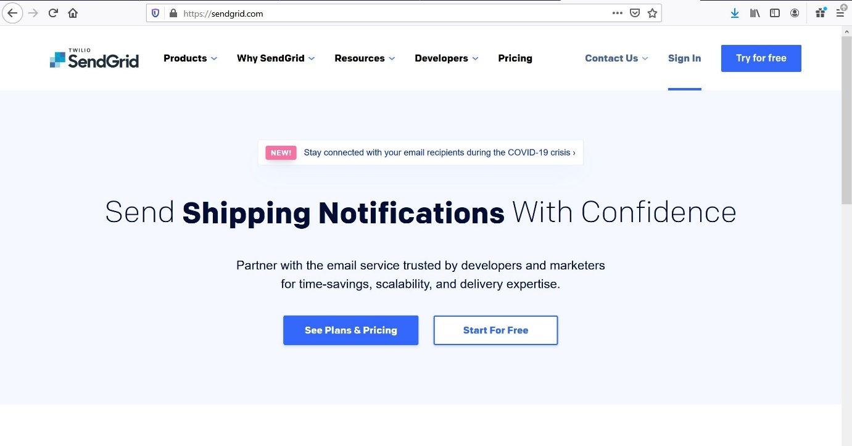

Step 2: Sign in or create an account if you have not already.

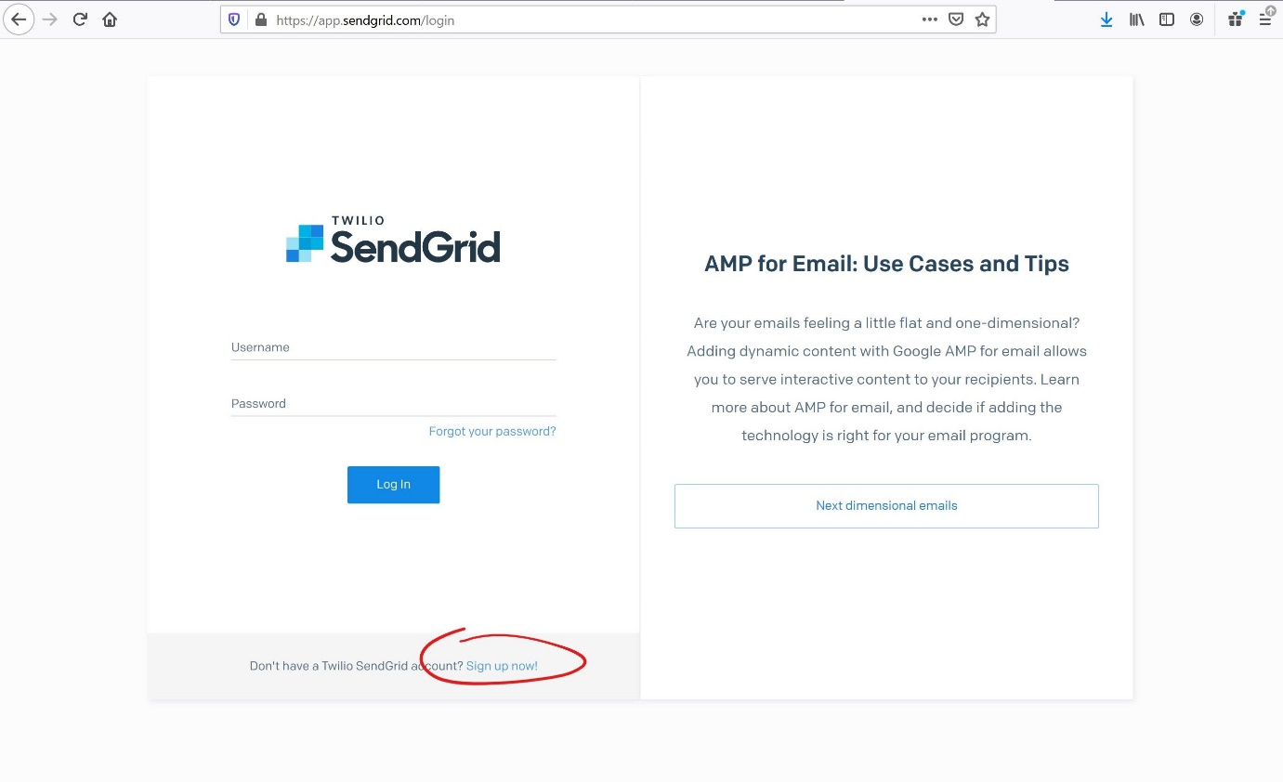

Step 3: Once your account is done being created, you want to go to the Integration Guide under Email API.

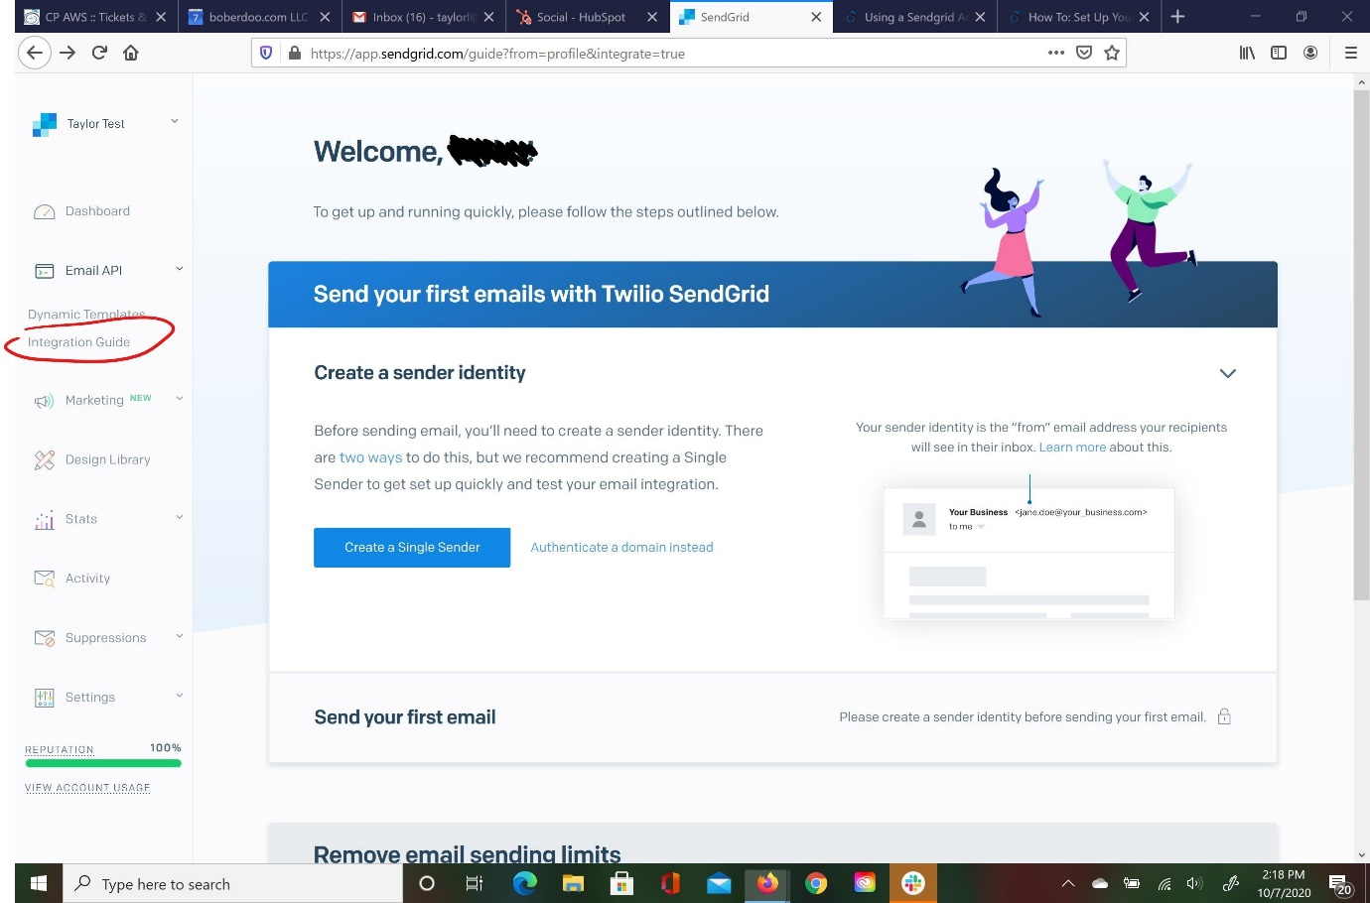

Step 4: Name and create your key.

